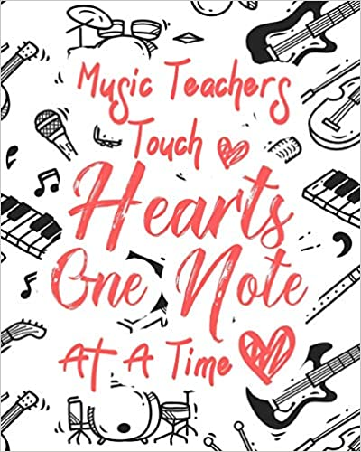 West Central

Music Teachers Club

P.O. Box 615

Willmar, MN 56201

[www.westcentralmusicteachers.com](http://www.westcentralmusicteachers.com)

2020-2021 Newsletter

Dear Members of WCMTC:

Since February twenty twenty “It Was a Very Strange Year”

It was a very strange year for piano teaching and other good things.

We social distanced and wore facial masks to keep us free from CoVid.

(Sung to the tune of It Was a Very Good Year)

Our organization values each one of you and your contribution in teaching music. During these uncertain times, music has been a calming, inspiring source that has helped many people get through stressful times. Through your teaching you are passing on the gift of music in your students that they will treasure and enjoy for a lifetime.

Christine Schneider and Cheryl Schmidt attended the MFMC State Meeting via Zoom on July 22, 2020. Reports were given from all the various committees. A special thank you to Cheryl Schmidt who serves on our state board and works with the finances, web site and Half Notes Newsletter.

Next year is the Minnesota Federation of Music Clubs 100th Anniversary. It will take place at the Holiday Inn in Lakeville, Minnesota on July 14-15, 2021. Schmitt Music will be on site. Special musical guests will perform. All the past presidents of MFMC will be invited to this event.

The Festival Online System is still being worked on to refine the process.

Please fill out the enclosed Membership Form and return it by September 12th.

Remember YOU make this club and we need all of you to help us continue especially during this strange time in our lives. Keep praying for a cure.

Executive committee: OFFICERS FOR 2020-2021:

PRESIDENT: Sharon Willen 320-354-5341 [swillen@tds.net](mailto:swillen@tds.net)

SECRETARY: Marla Adrian 320-254-3368

TREASURER: Christine Schneider 320-235-9387 dannyboy2220@gmail.com

FESTIVAL GROUPS: FESTIVAL CHAIRPERSON:

Music Makers of Willmar (Willmar I) Su Michelson

Festival: 320-235-7436

Location: Vinje Lutheran Church, Willmar su[michelson@gmail.com](mailto:michelson@gmail.com)

West Central Strings (Willmar II) Barb Swanson

Festival: 320-235-7468

Location: Vinje Lutheran Church [swanhome3@gmail.com](mailto:swanhome3@gmail.com)

Cadenza Club (Willmar East) Yvonne Rammel

Festival: 320-286-5283

Location: Gethsemane Lutheran Church [rammel@centurylink.net](mailto:rammel@centurylink.net)

Dassel

Keyboard Kids (Willmar North) Sharon Willen

Festival: 320-354-5341

Location: Faith Lutheran Church, Spicer [swillen@tds.net](mailto:swillen@tds.net)

We hope and pray that Festivals will be able to occur in 2021 some way or another. Those dates will be made available to you when we know more.